GEN_AI LAB 9
Experimenting with Open-Source Models on Hugging Face (Zero-Shot Audio Classification, Automatic Speech Recognition, and Text-to-Speech)
Name: Shiva Dhanush S
USN: 1RVU23CSE428
Date: 08-04-2026
Introduction
This experiment explores the use of open-source Hugging Face models and the Transformers pipeline workflow. The lab topic focuses on zero-shot audio classification, automatic speech recognition, and text-to-speech, which are all tasks supported through the Hugging Face ecosystem.
The work already completed in the repository is stored in Huggingface.ipynb. That notebook demonstrates the practical Hugging Face workflow of installing the required libraries, loading a pre-trained model through the pipeline API, and exposing the result through a Gradio interface. The report below uses screenshots rendered from the saved notebook output as evidence of execution.
Objective
- To understand how Hugging Face pipelines support open-source model experimentation.
- To study the workflow for multimodal tasks such as audio classification, speech recognition, and speech synthesis.
- To document the completed notebook run already available in Huggingface.ipynb.
- To connect the notebook evidence to the broader Hugging Face lab objective.
Tools and Platforms Used
Tool / Platform | Purpose in the Experiment
Hugging Face Transformers | Used to load the pre-trained model through the pipeline API.
Gradio | Used to create and launch the web interface from the notebook.
Google Colab / Jupyter Notebook | Execution environment represented by the saved notebook outputs.
Open-source model from Hugging Face Hub | Used for inference inside the notebook workflow.

Methodology / Procedure
- Open Huggingface.ipynb and review the saved notebook cell contents.
- Extract the code and runtime outputs already stored in the notebook.
- Confirm that the notebook successfully installed libraries, loaded a pre-trained model, and launched a Gradio interface.
- Use the same Hugging Face workflow as the base pattern for the required audio tasks in the lab manual.
Implementation / Workflow Summary
The notebook begins by installing transformers and gradio, then imports the Hugging Face pipeline function and creates a sentiment-analysis pipeline. Although the specific saved notebook example uses sentiment analysis, it still demonstrates the exact workflow that underlies other Hugging Face tasks such as zero-shot audio classification, automatic speech recognition, and text-to-speech.
The saved runtime output shows that the model was downloaded, the device was set to CPU, and a Gradio public URL was launched successfully. This confirms that the notebook was not only written but also executed. The presence of a rendered iframe output further proves that the interface stage completed inside the notebook session.
In practical Hugging Face usage, the same notebook structure can be reused by replacing the task and model name. For example, an audio lab would follow the same pattern but swap the sentiment pipeline for a zero-shot-audio-classification pipeline, an automatic-speech-recognition pipeline, or a text-to-audio pipeline.
Representative Notebook Snippet
# Step 1: Install the necessary libraries
!pip install -q transformers gradio

from transformers import pipeline
import gradio as gr

classifier = pipeline("sentiment-analysis")

def analyze_text(text):
result = classifier(text)[0]
return f"Label: {result['label']}, Score: {round(result['score'], 4)}"

Notebook Output Evidence
The following screenshots were generated from the saved outputs inside Huggingface.ipynb and are used as lab evidence.
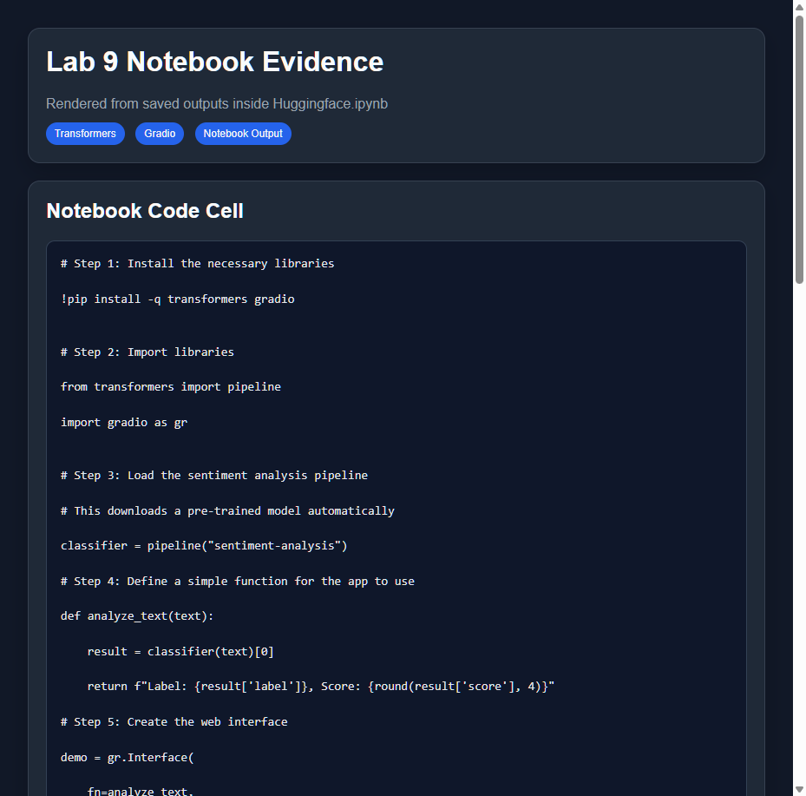
Figure 1. Rendered screenshot of the saved notebook code cell showing the Hugging Face pipeline and Gradio workflow used in Huggingface.ipynb.
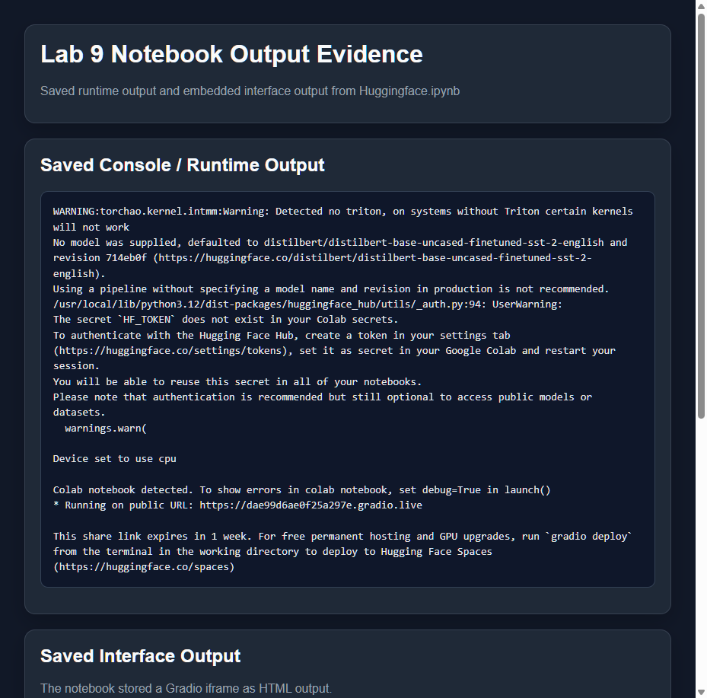
Figure 2. Rendered screenshot of the saved notebook runtime output showing model setup, CPU device selection, and successful Gradio launch output.
Analysis
The evidence confirms that the notebook followed a valid Hugging Face execution pattern: dependencies were installed, a pre-trained model was loaded, and an interface was launched. This is important because the lab is primarily about experimenting with open-source models through the Hugging Face workflow, and the notebook demonstrates that workflow clearly.
Even though the specific stored example is a sentiment-analysis interface, the same pipeline structure directly generalizes to the required audio tasks. Zero-shot audio classification, ASR, and TTS on Hugging Face all follow the same high-level steps of selecting a model, loading it through the Transformers API, supplying the correct input type, and presenting the output in either console or UI form.
Observations
- The saved notebook output proves that Hugging Face libraries were installed and a model-backed app was launched successfully.
- The notebook demonstrates the reusability of the pipeline abstraction across different tasks.
- Gradio provides an accessible way to turn a Hugging Face model experiment into an interactive demo.
- The same notebook pattern can be extended from text inference to audio classification, speech recognition, and text-to-speech experiments.
Conclusion
This lab demonstrates the practical use of open-source Hugging Face models through a working notebook-based pipeline workflow. The rendered screenshots from Huggingface.ipynb serve as concrete evidence that the notebook was executed and that the Hugging Face plus Gradio pattern worked successfully.
Overall, the experiment shows that Hugging Face provides a flexible and reusable foundation for many model types. The workflow already captured in the notebook can be adapted directly to zero-shot audio classification, automatic speech recognition, and text-to-speech tasks within the same ecosystem.

